**Table of Contents**

**FPT International School**

--- o0o ---

**PROJECT REPORT**

**Shale-PIZZAAsss**

Batch: T1803E

Semester: 1

Group: 2

1. Nguyen Tien Thinh (Team Leader)
2. Pham Thanh Dat
3. Nguyen Van Hoan

Instructor: Trinh Quang Hoa

**Hanoi - 09/2018**

1. Problem Definition 4

i. Introduction 4

ii. Implementation Environment 4

User Stories 5

1.1 Customers 5

iii. Items for sale 5

iv. View Product 5

v. Purchase Product 5

vi. Give Feedback 5

vii. Contact Us 5

viii. View Caterogies 5

ix. View Stores Location 5

2. Database 6

2.1 DB Relationship Diagram 6

2.2 Table 1 (Example: Account) 6

2.3 Table 2 (Example: Caegory) 7

2.4 Table 3 (Example: Product) 7

2.5 … 7

2.6 … 7

2.7 ... 7

2.8 ... 7

3. UI\UX 8

3.1 GUI 1 (Example: Login Form) 8

3.2 GUI 2 (Example: Address Book Form) 8

3.3 GUI 3 9

3.4 … 9

3.5 … 10

3.6 … 10

3.7 ... 10

3.8 ... 10

3.9 ... 10

3.10 ... 10

3.11 ... 10

4. Summary 11

# Problem Definition

### Introduction

Shale-PIZZAAsss is famous for Pizzas, Pasta food. Shale-PIZZAAsss was opened with one restaurant in the year 1960 and now it has more than 1000 restaurant across the countries. A website needs to be designed must display the menus, Contact Us (so as to call a make order). Details of various franchise, locations, feedback must be included.

The Web site is to be created based on the following requirements.

1) Home Page must display the image section of the website.

2) Color combination must be made precise in the application.

3) Links such as

- Home

- Menu

i. Pizza

ii. Garlic Breads

iii. Pizza Sandwiches

iv. Desserts

v. Beverages

- Menu Download

- Store Location

- Locations

- Feedback

- Franchise Info

4) There should be a “Contact Us” page which will have the Address of the Company which should be displayed using GeoLocation API (eg. GoogleMaps) and the email address which when clicked will invoke the local mail client from where they can send an email.

5) Other Additional Links such as

- Weekend Special

- Combo offers

- Gallery

6) Navigation of the project must be made precise

7) Look and feel must be made user friendly..

### Implementation Environment

• HTML5/ CSS/ JavaScript

• Boostrap / Jquery

• Amazing Slider

• Dreamweaver

• Google Chrome/ Mozilla FireFox/ Internet Explorer

• Methodology: Scrum

# User Stories

## Customers

### Items for sale

As a customer, I can view lists of items for sale and search by name.

### View Product

As a customer, I want to view the details of your product to consider to purchase or not.

### Purchase Product

As a customer, I want to purchase your product, can change quantity of the product, and see the total of my deal.

### Give Feedback

As customer I want to give feedback about service/product to the service provider.

### Contact Us

As customer, I want to send my contact and my message directly to the service provider.

As customer, I want to see the address of service provider in the interface map.

### View Caterogies

As customer, I want to view the caterogies of product sorted by Gender/ Kind of product.

### View Stores Location

As customer, I want to view the Stores Location in each Country, State and City.

### View gallery

As customer, I want to view gallery of Shale-PIZZAsss

# Flowchart

## Purchase Products

Start

Select Category

Select Product

Add to cart

Process Payment

End

Continue Shoping

Check out

## Search Products

Found

Start

Select Category

Enter keyword

Display Result

End

Not found

Search

## Site map

Home page

List product

Single product

Shopping cart

Checkout

Complete order

Store location

Location

Feedback

Franchise

Compo

Weekend special

Gallery

Contact Us

# UI\UX

## Home page

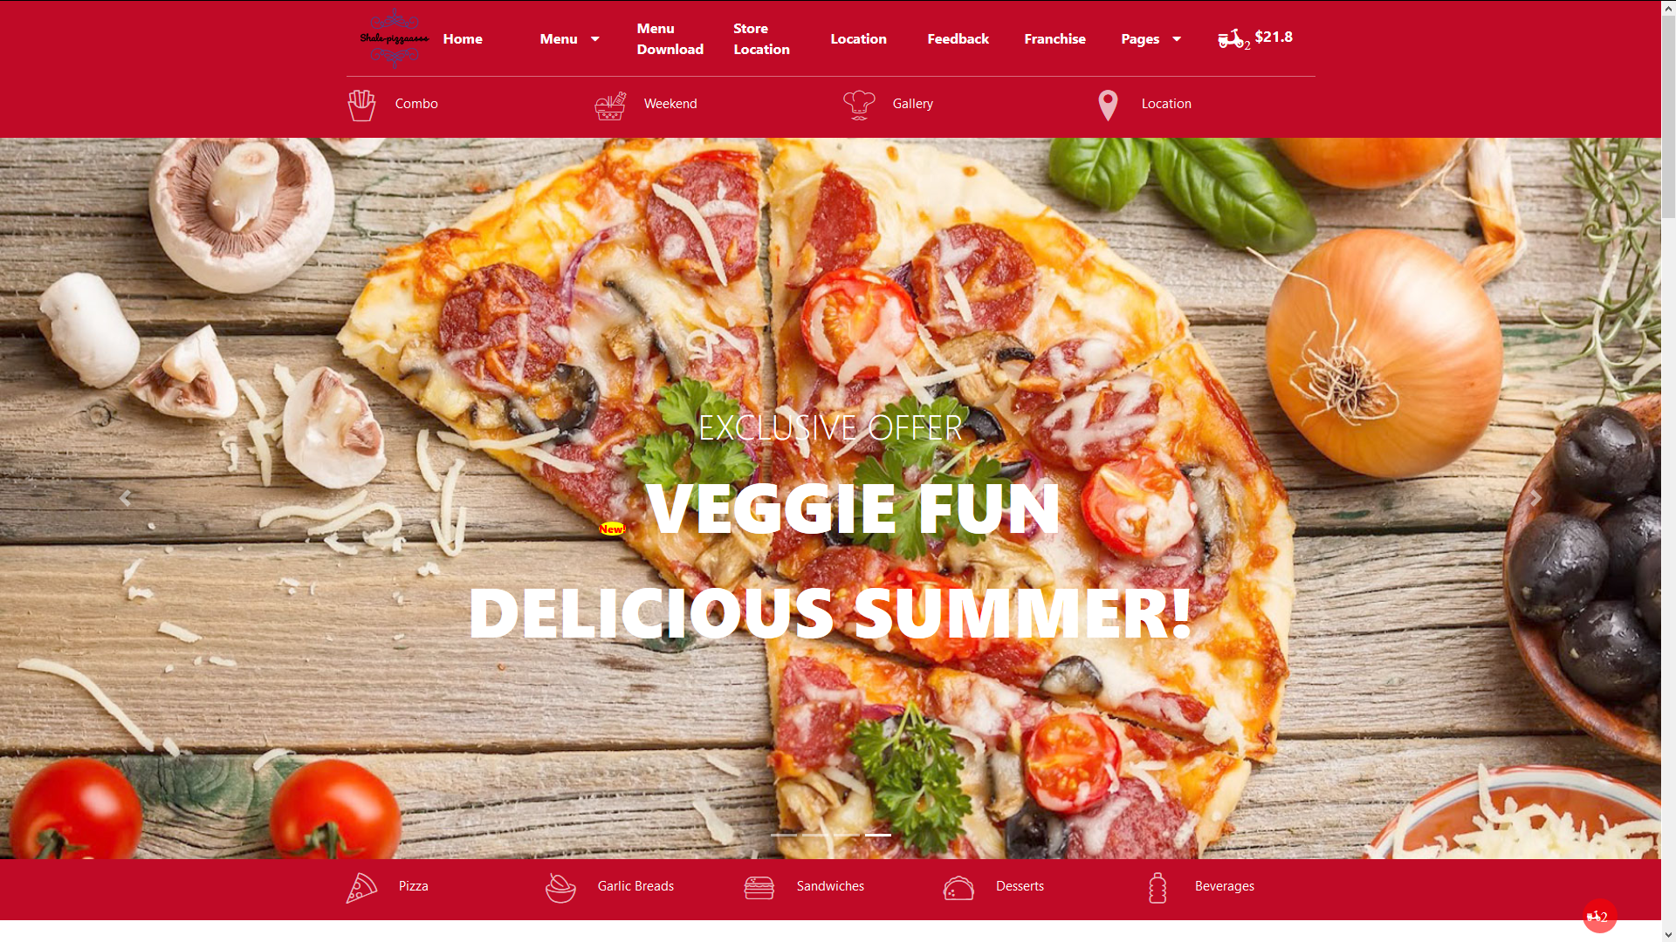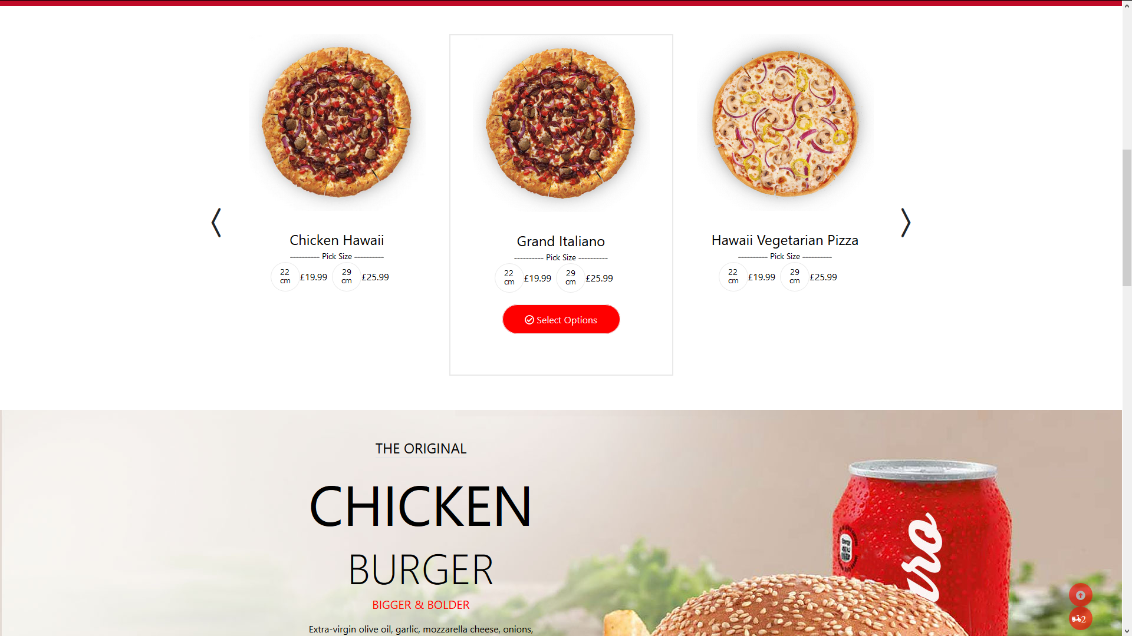 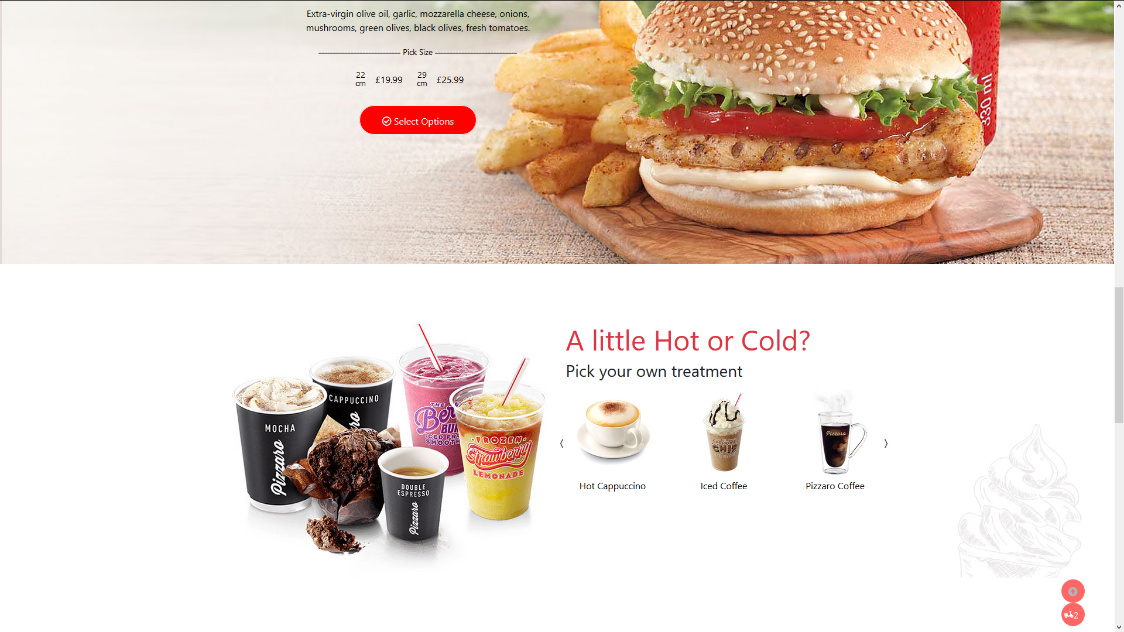 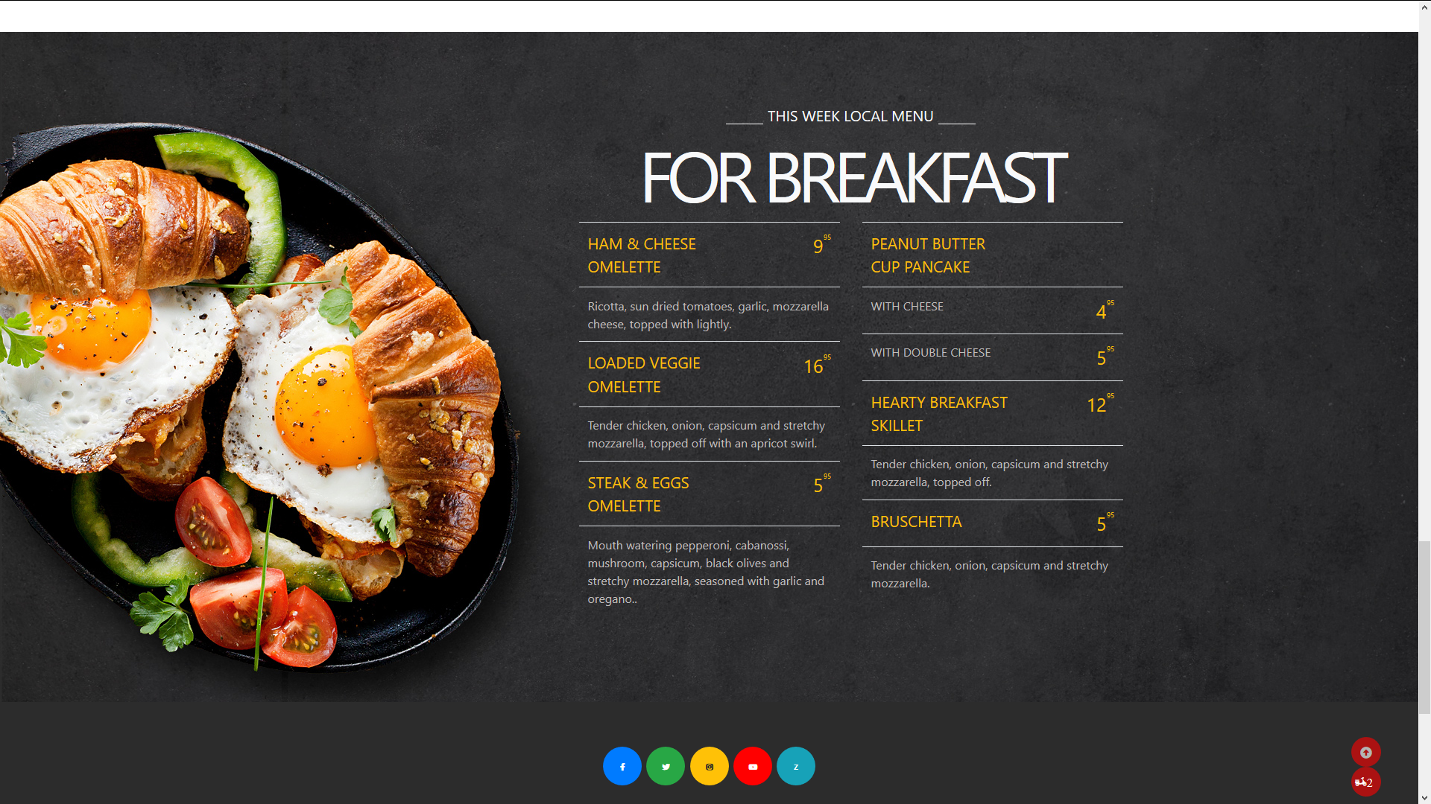

## List product

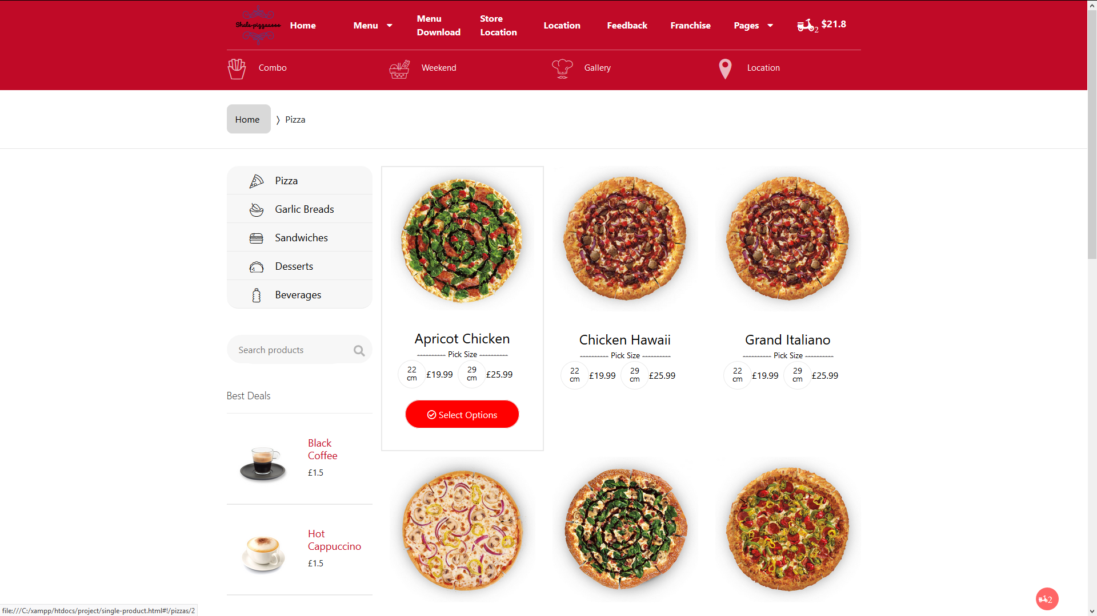 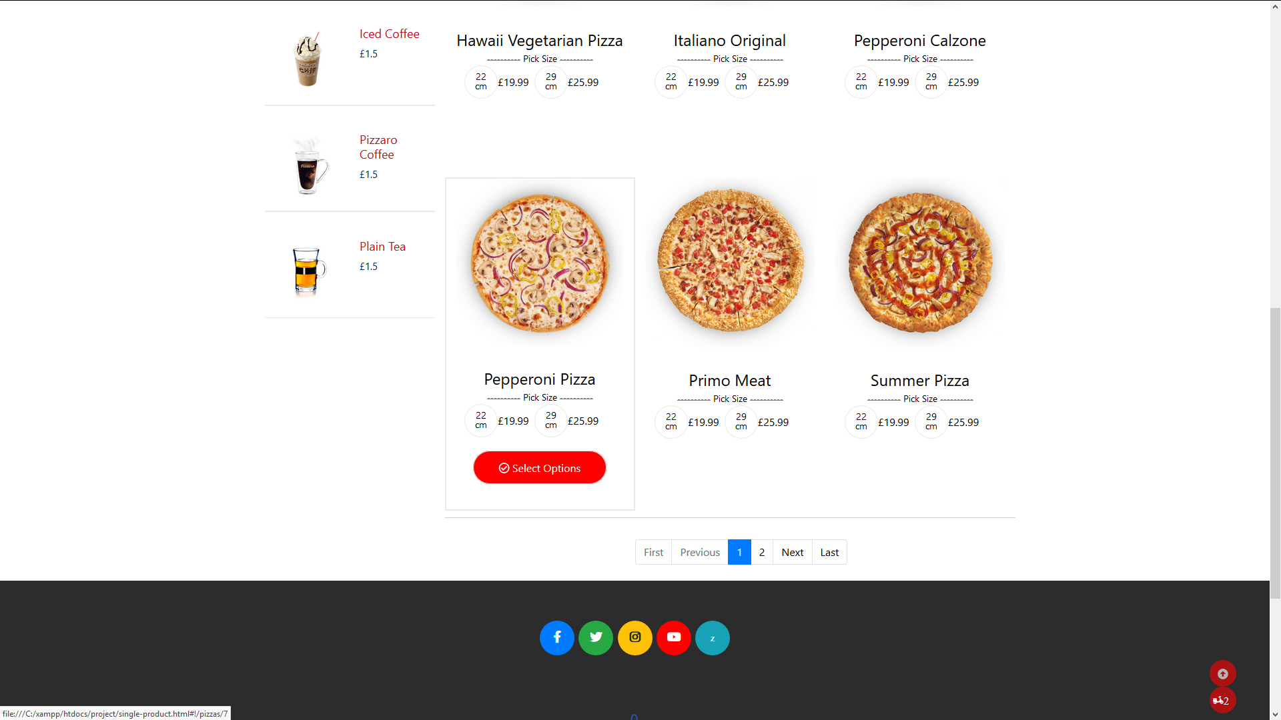

## Single product

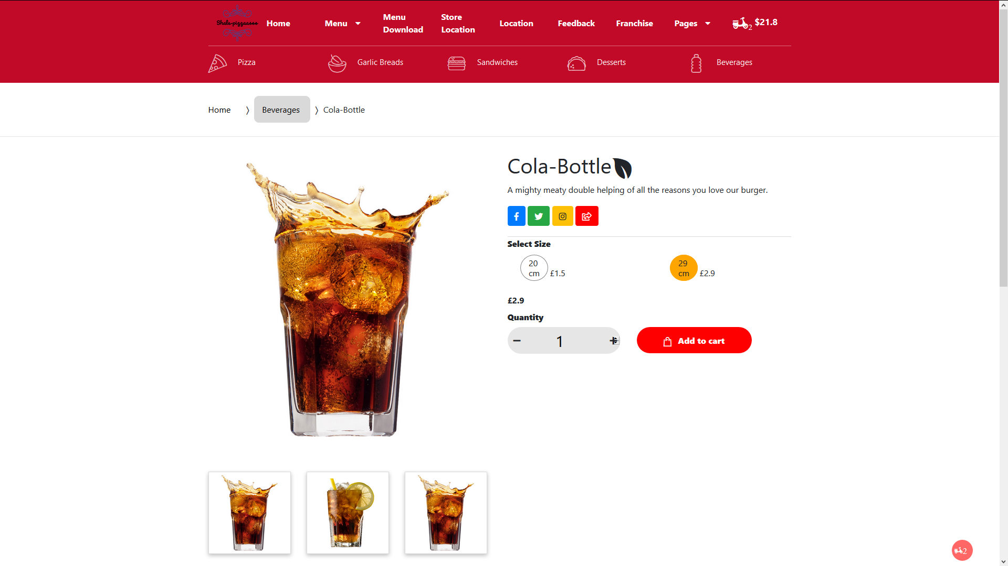 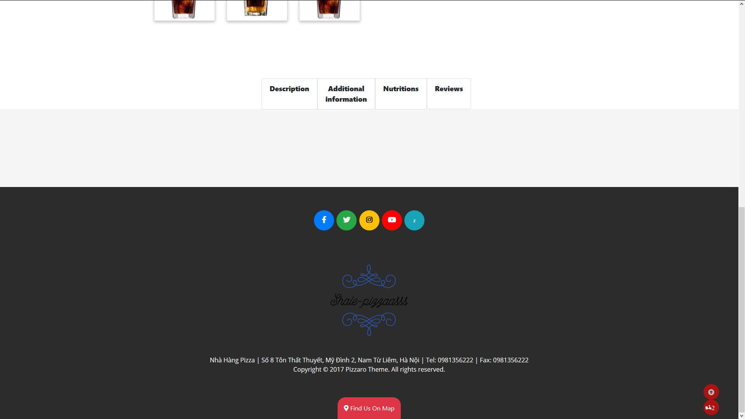

## Shopping cart

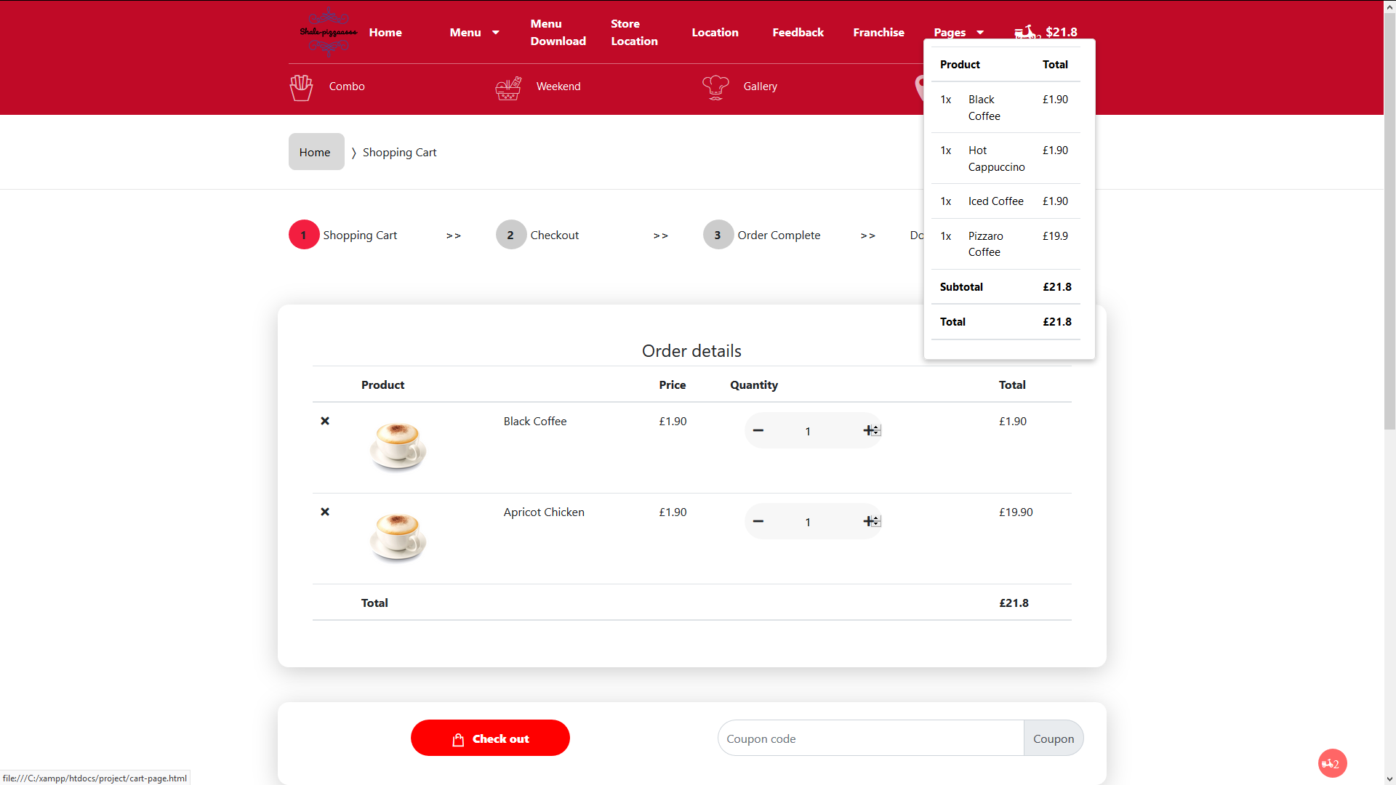 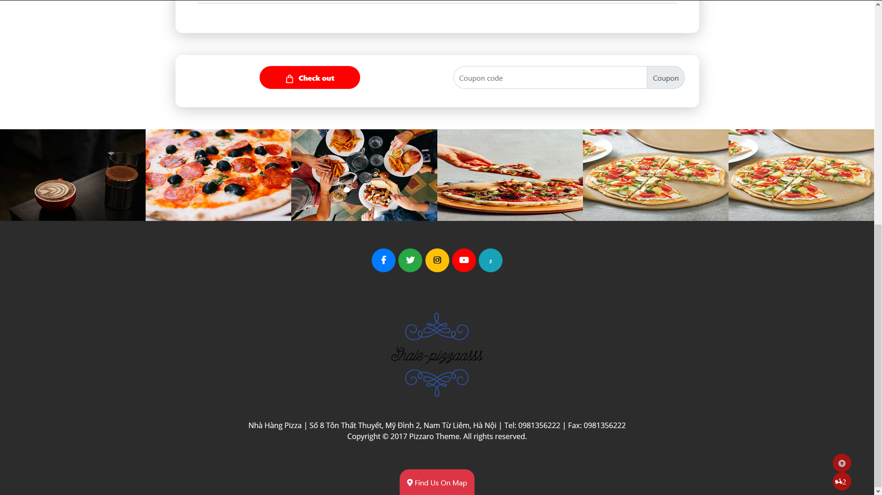

## Checkout

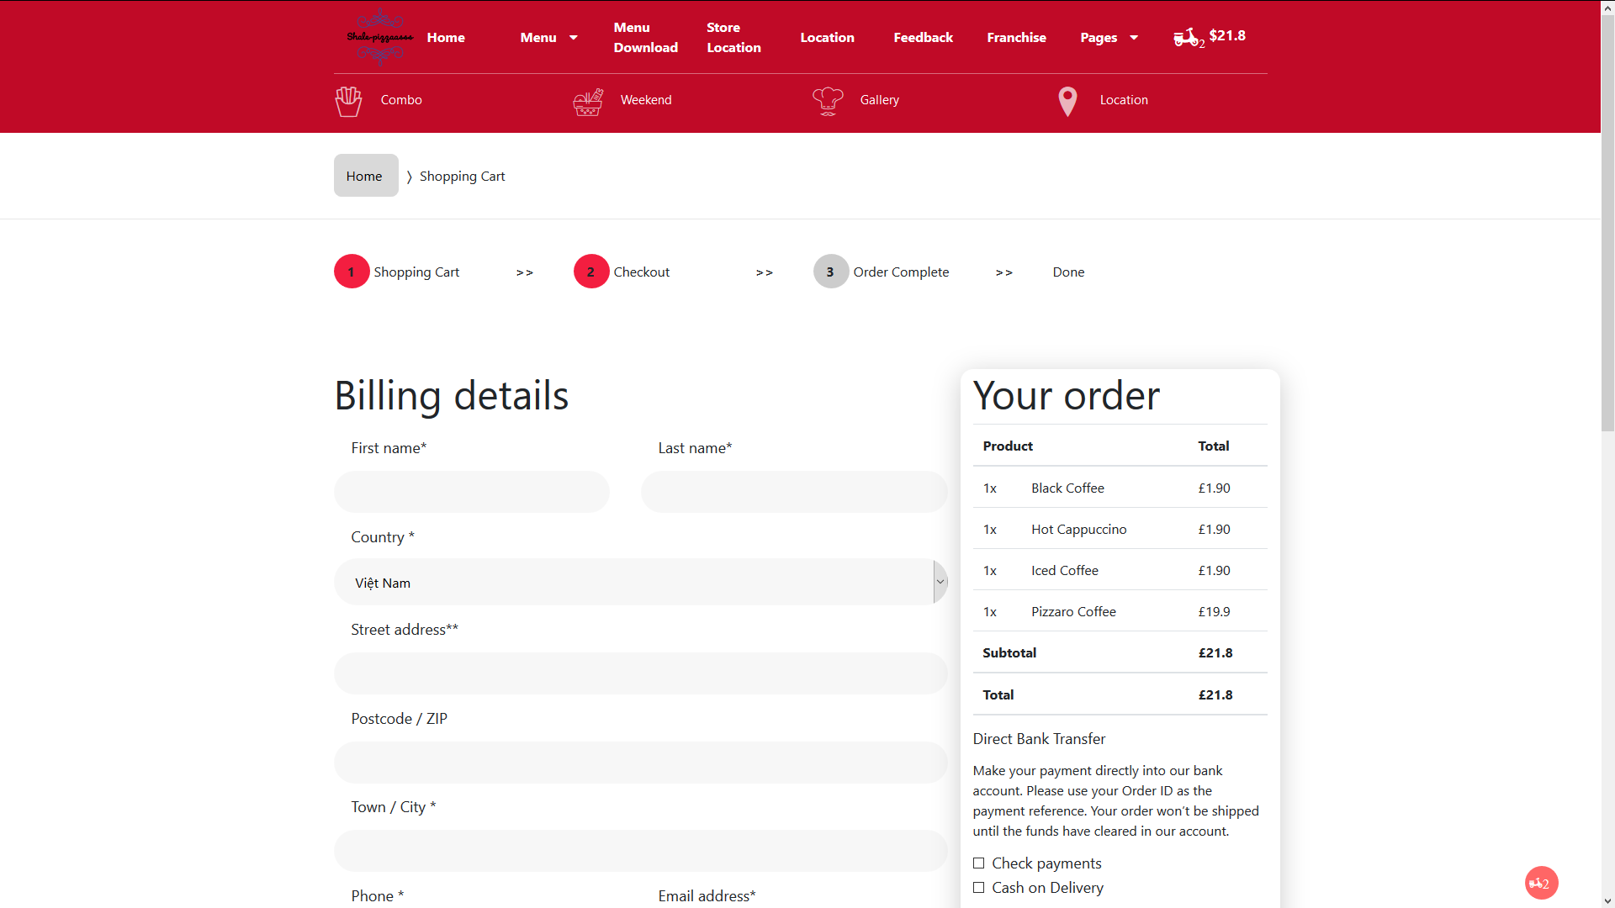 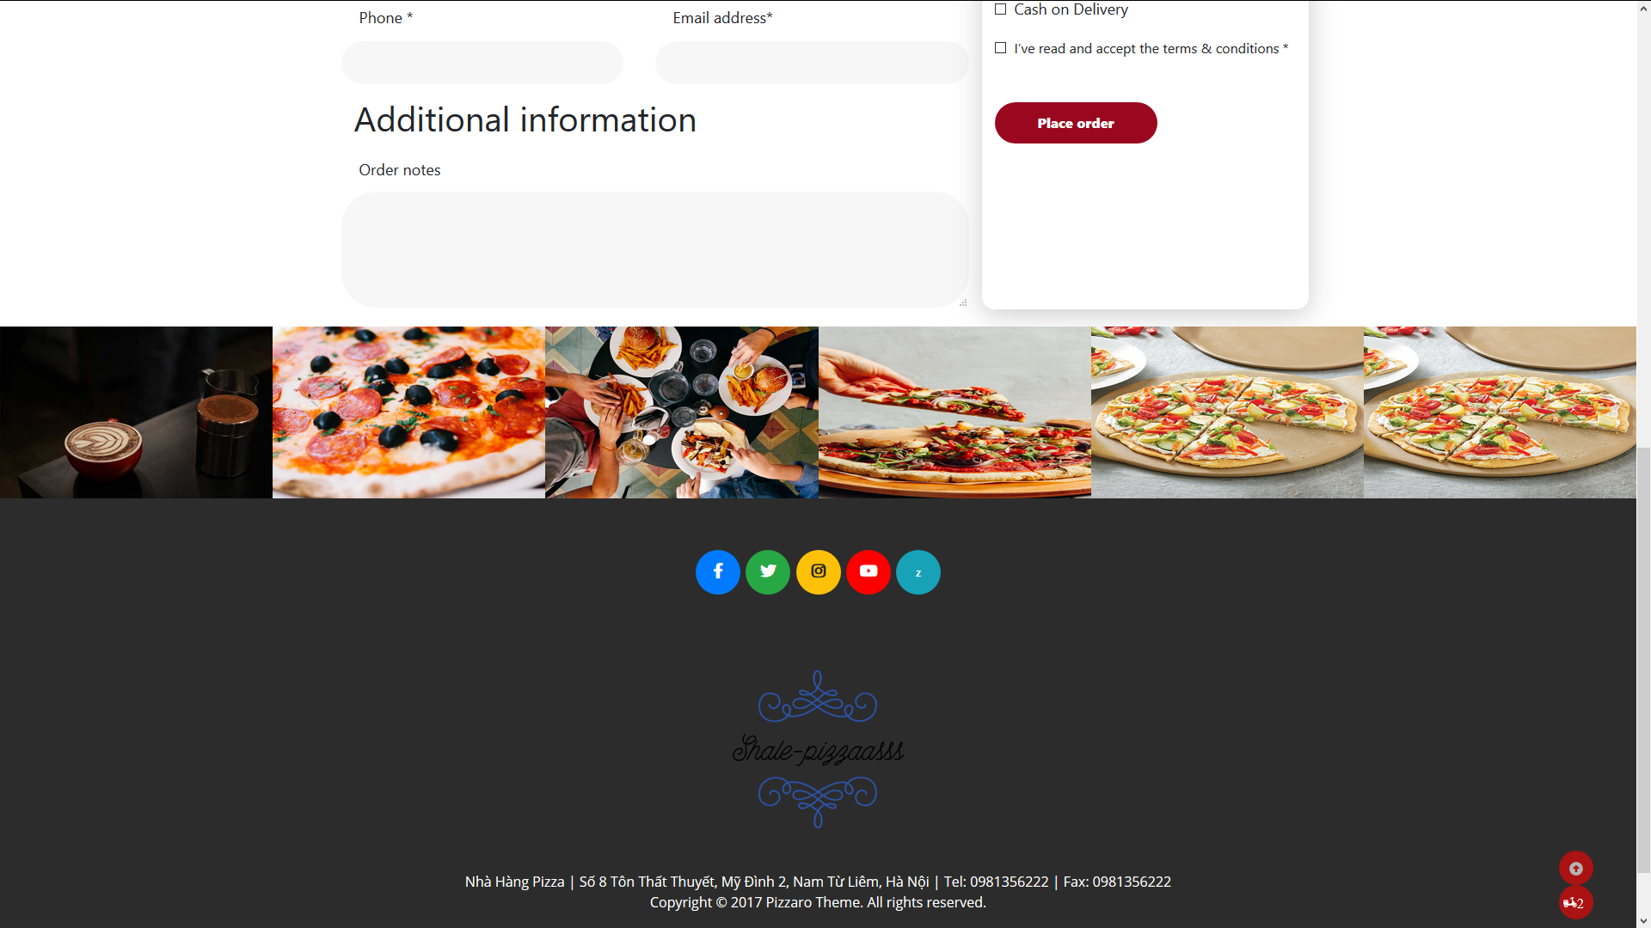

## Complete Order

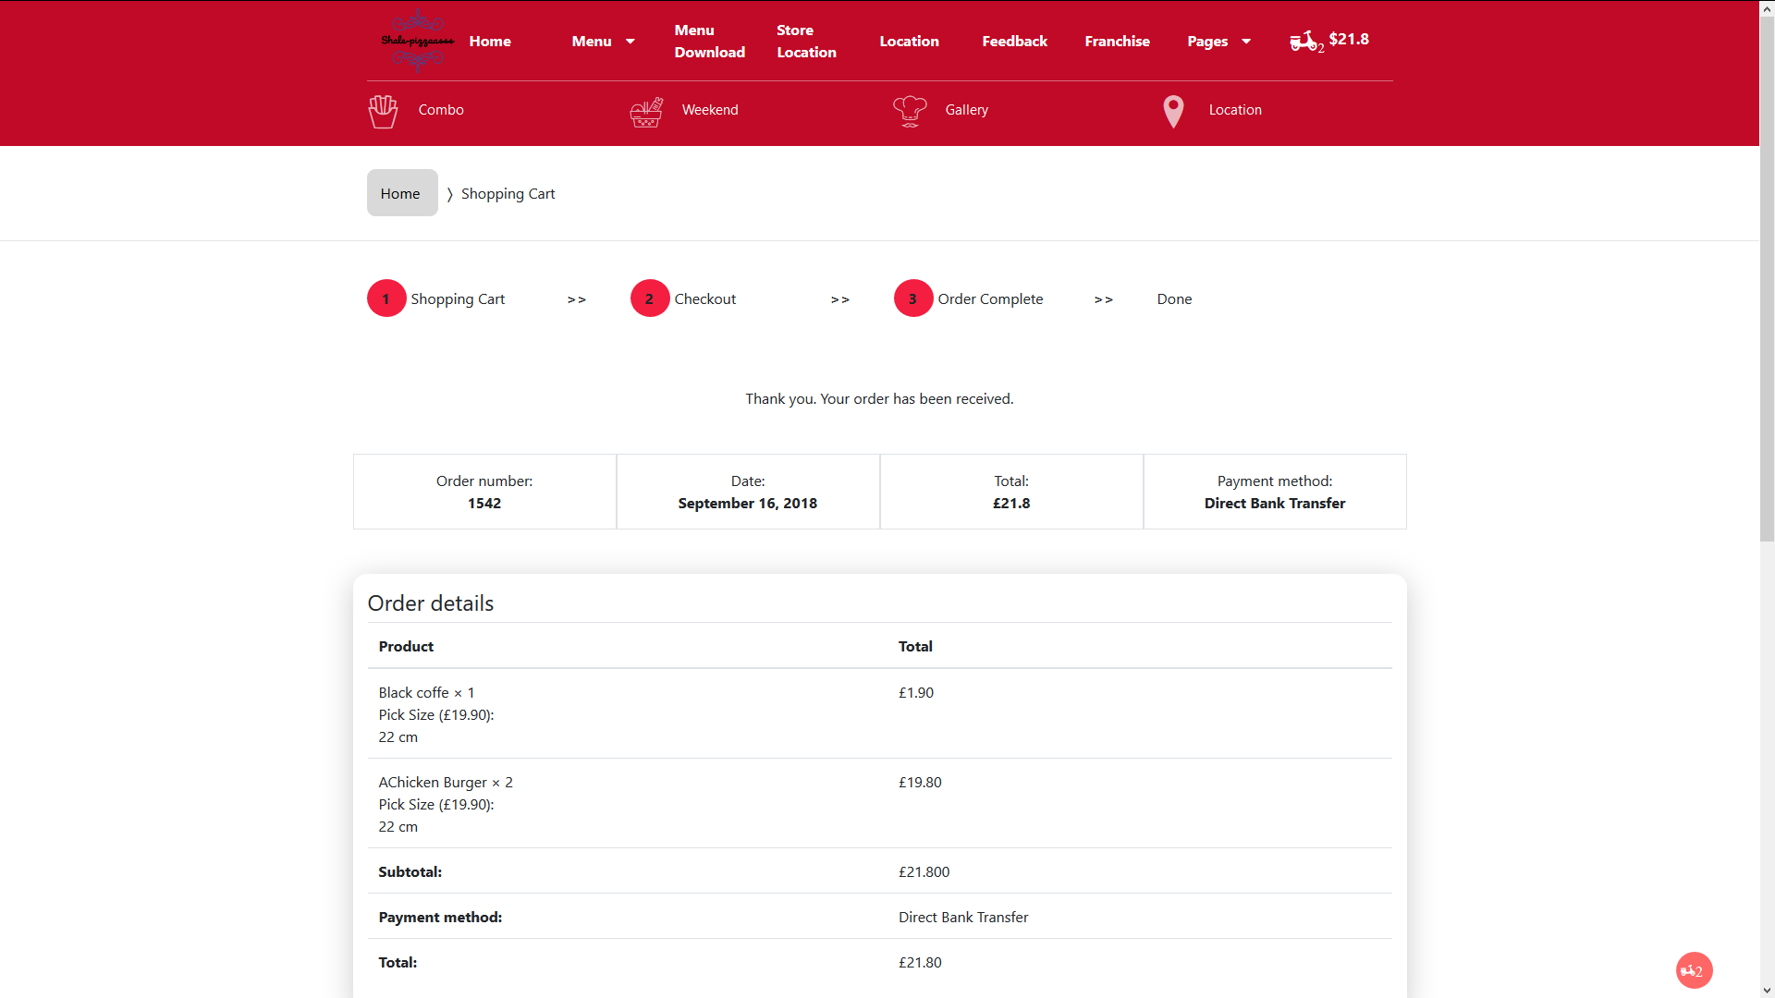 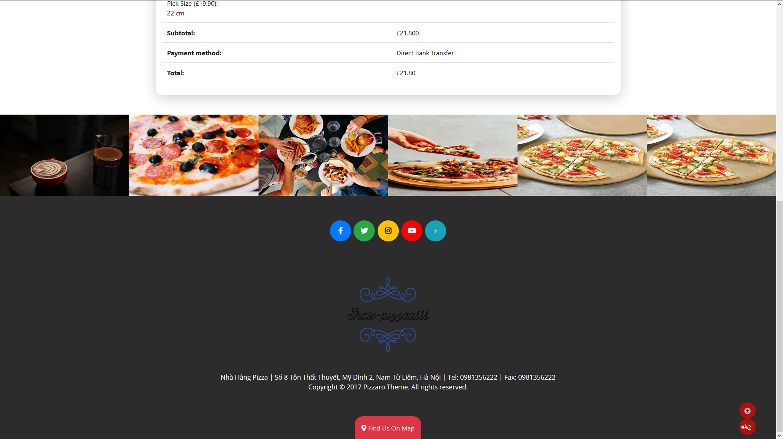

## Feedback

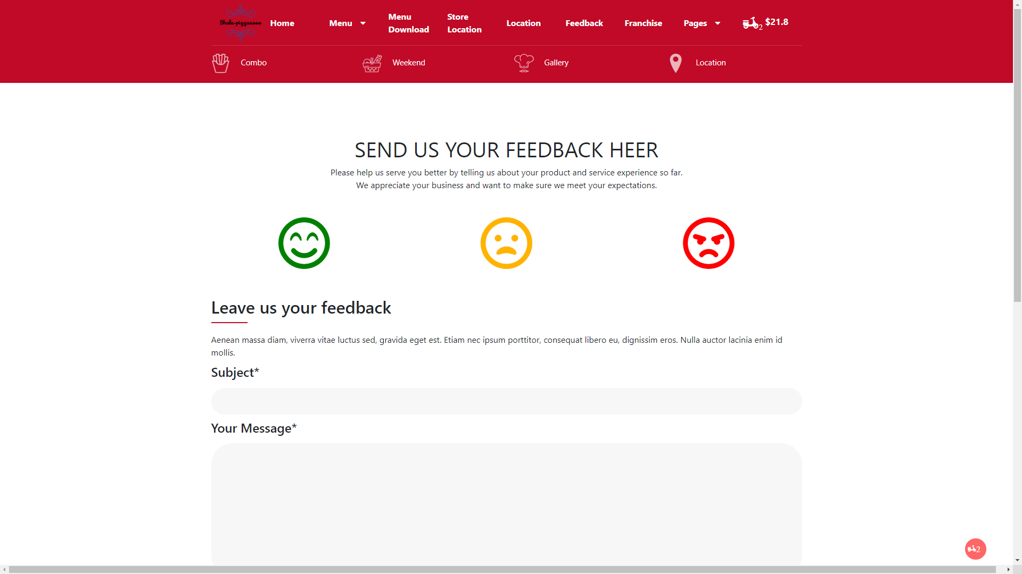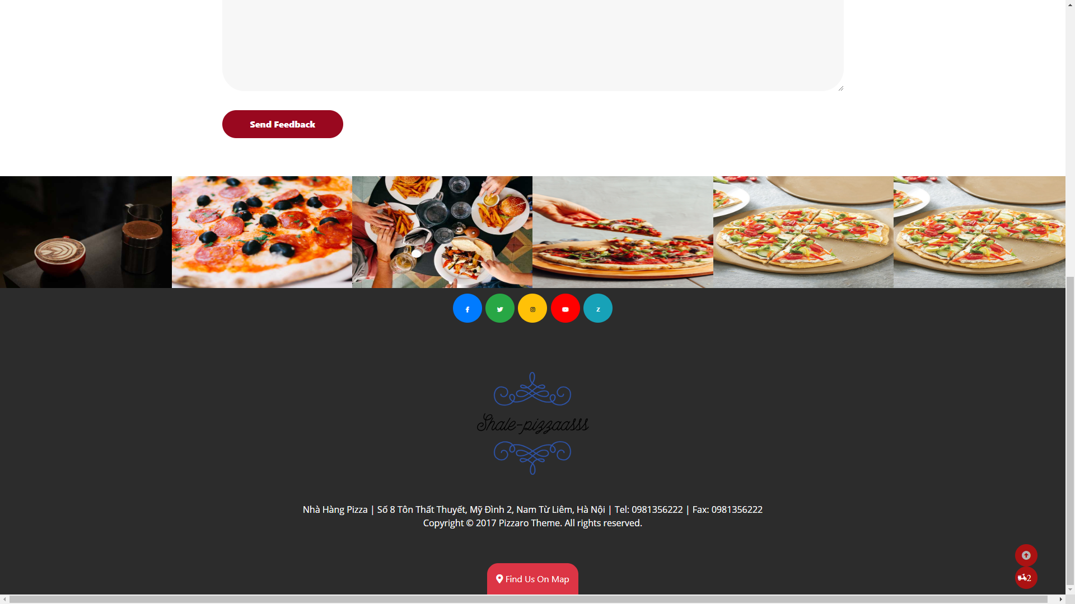

## ...

## ...

## ...

## ...

# Summary

|  |  |  |
| --- | --- | --- |
| **ID** | **Responsible** | **Task** |
| **1** | 1. Nguyen Tien Thinh | Home Page, Product Details, Checkout, Contact us, Shopping cart; |
| **2** | 2. Nguyen Van Hoan | List product, Combo offers, Location, Store location, Order received; |
| **3** | 3 Pham Thanh Dat | Feedback, Franchise, Gallery, Weekend special; |